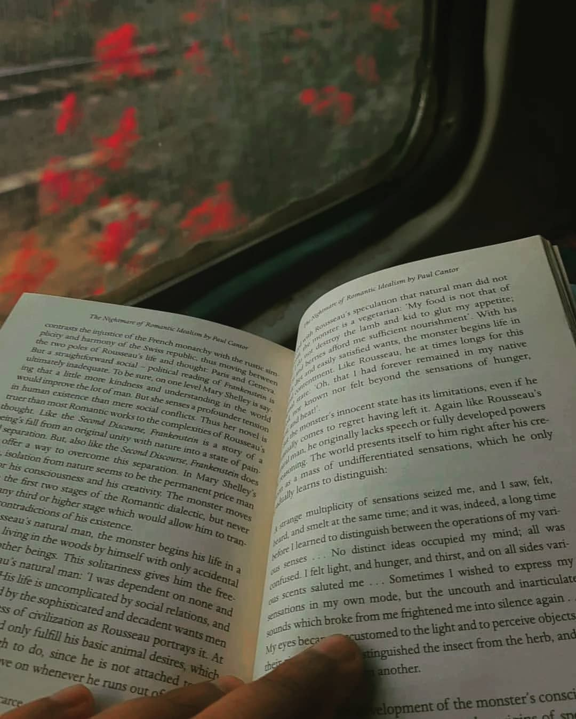
I've often been told that much of my work, be it poetry, prose, or music, often deals in melancholia and might even be called "depressive" to some degree.

I agree.

I've never heard of a human who doesn't know how to deal with happiness, happiness, isn't very confusing, it isn't very challenging, It is like riding a brand new vehicle on a smooth highway.

If your car never broke down, you'd never have had the need to open up the manual, read up about the parts, look at quora endlessly to find solutions. You'd never have felt the need to "know" if someone other than you has been stuck for 5 hours on a highway in the middle of the night because they themselves did not know what a dysfunctional radiator was like.

Similarly, you do not require a "manual for life" , as long
as things are going as planned. You're happy, you do not need to understand why "personal is political" , or why "one must imagine sisyphus happy".

The truth is, you only find the answers to the questions you've asked, and even if the most profound of the answers about our existence were presented to you, you'd just pass them by, if you weren't looking for them.

I write about the unpleasant aspects of our existence to provide them validity, to grab them by their hands and drag them in the middle of the street that our society walks on. To show the world that it is no better than the bachelor who just sweeps all the dirt under the rug, and into the darker corners of his room, where it may rot, and smell, and cause diseases, only to get covered up by fragrances and deodrants, which a guest might then perceive as pleasant.

I despise pretense, I despise ignorance, I despise that we look down upon those beaten and depressed, because if you are self aware, and worthy of being called human via your virtues of sensitivity, compassion, and benevolence, yet, are not depressed at the look of how things are around us all, then there's something seriously wrong with you.

Viktor Frankl, once said, that an abnormal reaction to an abnormal situation is a normal reaction, and if the complete madhouse that our world is right now, seems normal to you, I'd be glad to be called a depressive.

